CHEMISTRY 2 (BIOCHEMISTRY)
Department of Biochemistry
Benha University, Agriculture College

PRACTICAL

The Topics :
I CARBOHYDRATES
- General tests: Molisch, Benedict, Fehling and Barfoid
- Specific tests: Seliwanoff.
- Tests for polysaccharide: (Iodine, and Hydrolysis of polysaccharide ).
II LIPIDS
1- General tests: (Solubility test of lipids, Grease spot, Emulsification of lipids).
2- Specific test: (Copper acetate, iodine, Iodine number determination, Acid value, Saponification of oils and fats, Saponification value.)
III PROTEINS
1- General tests:- a- Protein composition test. b- Precipitation of proteins; By salts of heavy metals, By alkaloidal reagents. By neutral salts: Half saturation and Complete saturation, and By alcohol. c- Coagulation of proteins by heat. d- Biuret’s test, Ninhydrin’s test.
2- Specific tests for Amino acids: ( Milon’s test, Xanthoproteic’s test, Lead acetate test, and sakaguchi’s test.

Carbohydrates

Carbohydrates are polyhydroxy aldehydes and ketones or substances that hydrolyze to yield polyhydroxy aldehydes and ketones. Aldehydes (– CHO) and ketones (=CO) constitute the major groups in carbohydrates. Carbohydrates are mainly divided into monosaccharides, disaccharides and Polysaccharides. The commonly occurring monosaccharides includes glucose, fructose, galactose, ribose etc. The two monosaccharides combined together to form disaccharides which include sucrose, lactose and maltose. Starch and cellulose fall into the category of polysaccharides which consists of many monosaccharide residues.
- Molisch’s Test:
This test is specific for all carbohydrates, Monosaccharide gives a rapid positive test, Disaccharides and polysaccharides react slower. Principle: The test reagent dehydrates pentoses to form furfural and dehydrates hexoses to form 5- hydroxymethyl furfural. The furfurals further react with α-naphthol present in the test reagent to produce a purple product.

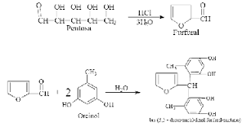

Method:
•Add 2 drops of the α-naphthol solution (5% in ethanol, prepare fresh) to 2 ml of test solution in a test tube.
• Carefully, pour about 1 ml of conc. H2SO4 down the side of the tube so as to form two layers. • Carefully observe any colour change at the junction of the two liquids.
• Repeat the test, using water instead of the carbohydrate solution.
2. Fehling’s Test:
This forms the reduction test of carbohydrates. Fehling’s solution contains blue alkaline cupric hydroxide solution, heated with reducing sugars gets reduced to yellow or red cuprous oxide and is precipitated. Hence, formation of the yellow or brownish-red colored precipitate helps in the detection of reducing sugars in the test solution.
Preparation of Fehling's
solution A: Dissolve 35g of Cu2SO4.7H2O in water and make up to 500ml Preparation of Fehling's
solution B: Dissolve 120 g of KOH and 173 g of Sod. Pot. Tartarate (Rochelle salt) in water and make up to 500 ml
Fehling’s reagent: Equal volumes of Fehling A and Feling B are mixed to form a deep blue solution.
Note: If you do not have sodium potassium tartarate, it can prepared using tartaric acid as described below.
Method:
• Mix equal volumes of Fehling's solution A and B
. • Add 5 drops of the test solution (glucose, fructose, and sucrose solution) to the mixed Fehling's solution and boil.

Results
Glucose solution Orange-brown color is appeared. Fructose solution Orange-brown color is appeared. Sucrose solution No change.
Discussion:
Fehling's tests for aldehydes are used extensively in carbohydrate chemistry. A positive result is indicated by the formation of a brick red precipitate. Like other aldehydes, aldoses are easily oxidized to yield carboxylic acids. Cupric ion complexed with tartrate ion is reduced to cuprous oxide.
The cupric ion (Cu++) is complexed with the tartarate ion. Contact with an aldehyde group reduces it to a cuprous ion, which the precipitated as orange-brown Cu2O
The sucrose does not react with Fehling's reagent. Sucrose is a disaccharide of glucose and fructose. Most disaccharides are reducing sugars, sucrose is a notable exception, for it is a non-reducing sugar. The anomeric carbon of glucose is involved in the glucose- fructose bond and hence is not free to form the aldehyde in solution
On the other hand, glucose, a reducing sugar, reacts with Fehling's reagent to form an orange to red precipitate. Fehling's reagent is commonly used for reducing sugars but is known to be not specific for aldehydes. For example, fructose gives a positive test with Fehling's solution too, because fructose is converted to glucose and mannose under alkaline conditions. The conversion can be explained by the keto-enol tautomerism
The reduction of Fehling solution using fructose is not only to be attributed to the fact that the ketose is isomerized into an aldose. The treatment of fructose with alkali - e.g. Fehling solution - causes even decompostion of the carbon chain. More products with reducing capability are formed.
Note:
Fehling's test takes advantage of the ready reactivity of aldehydes by using the weak oxidizing agent cupric ion (Cu2+) in alkaline solution. In addition to the copper ion, Fehling's solution contains tartrate ion as a complexing agent to keep the copper ion in solution. Without the tartrate ions, cupric hydroxide would precipitate from the basic solution. The tartrate ion is unable to complex cuprous ion Cu+, so the reduction of Cu2+ to Cu+ by reducing sugars results in the formation of an orange to red precipitate of Cu2O. Copper-tartrate-complex

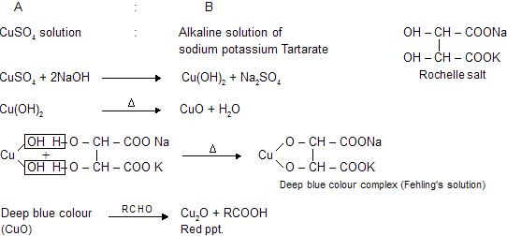

- Benedict's test:

Benedict modified the Fehling's test to produce a single solution which is more convenient for tests as well as being more stable than Fehling's reagent
Preparation of Benedict's reagent
Dissolve 173 g of sodium citrate and 100 g sodium carbonate in about 800 ml of warm water. Filter through a fluted filter paper into a 100 ml measuring cylinder and make up to 850 ml with water. Meanwhile dissolve 17.3 g of copper sulfate in about 100 ml of water and make up to 150 ml. Pour the first solution into a 2-liter beaker and slowly add the copper sulfate solution with stirring

Principle
The copper sulfate (CuSO4) present in Benedict's solution reacts with electrons from the aldehyde or ketone group of the reducing sugar. Reducing sugars are oxidized by the copper ion in solution to form a carboxylic acid and a reddish precipitate of copper (I) oxide

Method:
- Add 5 drops of the test solution to 2 ml of Benedict's reagent and place in a boiling water bath for 5 min. Orange-brown color is appeared.
- Compare the sensitivity of Benedict's and Fehling's test, using increasing dilutions of 1% glucose
- Both fehling's and benedict's test are used as a test for the presence of reducing sugars such as glucose, fructose, galactose, lactose and maltose, or more generally for the presence of aldehydes (except aromatic ones). It is often used in place of Fehling's solution.

CuSO₄ + Na₂CO₃ → CuCO₃ + Na₂SO4

2 Sodium citrate + CuCO3 → H₂CO₃ + complex of sodium citrate and cupper

complex of sodium citrate and cupper → Sodium citrate + Cu⁺² +2 OH⁻

RCHO + Cu ⁺² → RCOOH + Cu ⁺

Cu⁺ + OH ⁻ → Cu OH → Cu₂O (red ppt)
Or

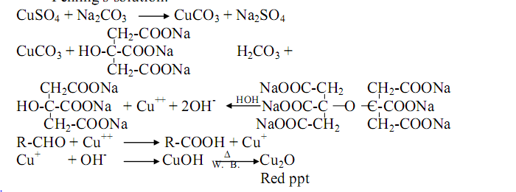

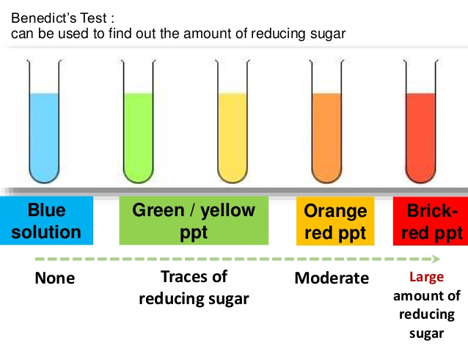

- Barfoed’s Test:

Barfoed's test is used to detect the presence of monosaccharide (reducing) sugars in solution. Barfoed's reagent, a mixture of ethanoic (acetic) acid and copper (II) acetate, is combined with the test solution and boiled. A red copper (II) oxide precipitate is formed will indicates the presence of reducing sugar. The reaction will be negative in the presence of disaccharide sugars because they are weaker reducing agents. This test is specific for monosaccharides. Due to the weakly acidic nature of Barfoed's reagent, it is reduced only by monosaccharides.

Preparation of Barfoed's reagent
Dissolve 13.3 g of copper acetate in about 200 ml of water and add 1.8 ml of glacial acetic acid.
Method:
• Add 1 ml of the test solution to 2 ml of Barfoed's reagent.
• Boil for 1 min and allow to stand.

RCHO + Cu ⁺² → RCOOH + Cu ⁺

- Iodine Test:
This test is used for the detection of starch in the solution. The blue black colour is due to the formation of starch-iodine complex. Starch contain polymer of α-amylose and amylopectin which forms a complex with iodine to give the blue black colour.
Iodine forms colored adsorption complexes with polysaccharides, starch gives a blue color with iodine, while glycogen and partially hydrolyzed starch react to form red- brown colors

Method:
Acidify the test solution (1% starch, glycogen or cellulose) with dilute HCl, then add two drops of iodine (0.005 N in 3% KI) and compare the colors obtained with that of water and iodine.

- Seliwanoff’s test:

It is a color reaction specific for ketoses. When conce: HCl is added. ketoses undergo dehydration to yield furfural derivatives more rapidly than aldoses. These derivatives form complexes with resorcinol to yield deep red color. The test reagent causes the dehydration of ketohexoses to form 5-hydroxymethylfurfural. 5hydroxymethylfurfural reacts with resorcinol present in the test reagent to produce a red product within two minutes. Aldohexoses reacts so more slowly to form the same product.

Test | Monosaccharide |  | Disaccharide |  | Polysaccharide
 | Glucose | Fructose | Sucrose | Lactose | Starch | Dextrin
1. Molisch
2. Fehling
3. Benedict
4. Barfoed
5. Iodine
6.Seliwanoff

LIPIDS
Determination of triglycerides
Esters of glycerol and fatty acids are known as glycerides. The trihydric alcohol glycerol can be esterified to give mono-, di-, and triglycerides. The fatty acids may be the same or different. On saponification, free glycerol and fatty acids are obtained
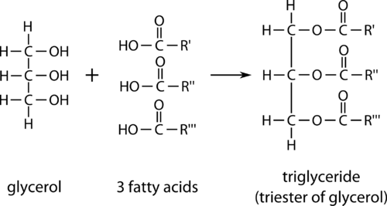

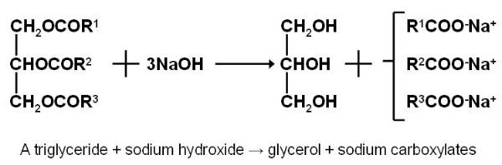
Naturally occuring glycerides are called fats or oils depending on whether they are solid or liquid at room temp. Animal fat is made up largely of triglycerides containing fully saturated fatty acids with straight chains and an even number of carbon atoms.
Methods for the quantitation of plasma triglycerides include chemical and enzymatic methods. The chemical methods require solvent extraction of the plasma to solublize triglycerides and to denature and remove protein. The extract is treated with an adsorbent material to remove phospholipids and interfering substances; isopropanol extracts are treated with a zeolite mixture or with alumina, and chloroform extracts are treated with silicic acid. Once isolated and purified, triglycerides are quantitated by either chemical or enzymatic reactions directed against their glycerol component
In the chemical methods: glycerol is released from triglycerides in the purified extracts by saponification with alcoholic potassium hydroxide. The glycerol is then oxidized to formaldehyde by sodium periodate. The formaldehyde is reacted with a chromotropic-sulfuric acid mixture to form a product that absorbs at 570 nm.
Qualitative tests of lipids:

- Solubility test
Fats are not dissolved in water due to their nature, non-polar (hydrophobic), but it is soluble in organic solvents such as chloroform, benzene, and boiling alcohol. Different lipids have ability to dissolve in different organic solvent. This property enable us to separate a mixture of fat from each other for example, undissolve phosphatide lipid in acetone; undissolve of cerebroside, as well as sphingomyline in the ether
.
Method:
• Place 0.5ml of oil in 6 test tubes clean, dry containing 4ml of different solvents (acetone, chloroform and ether and ethanol, cold ethanol and hot water),
• Shake the tubes thoroughly, then leave the solution for about one minute,
• Note if it separated into two layers , the oil are not dissolve; but if one layer homogeneous transparent formed , oil be dissolved in the solvent.

- Saponification test
Triacyl glycerol can be hydrolyzed into their component fatty acids and alcohols. This reaction can also be carried out in the laboratory by a process called saponification where the hydrolysis is carried out in the presence of a strong base (such as NaOH or KOH).
Saponification is a process of hydrolysis of oils or fat with alkaline and result in glycerol and salts of fatty acids (soap) and can be used the process of saponification in the separation of saponifiable materials from unsaponified (which are soluble in lipid). The process of saponification as follows:
Soap can be defined as mineral salts of fatty acids. The soap is soluble in water but insoluble in ether. Soap works on emulsification of oils and fats in the water as it works to reduce the attraction surface of the solution.
Method:
• Place 2 ml of oil in a large test tube (or flask).
• Add 4 ml of alcoholic potassium hydroxide (preferably add little small pieces of porcelain to regulate the boiling point).
• Boil the solution for 3 minutes. After this period, make sure it is perfectly saponification process, by taking a drop of the solution and mix with the water if oil separated indicates that the non-completion of the saponification. In this case, continued to boil until all the alcohol evaporates.
• Take the remaining solid material (soap) and add about 30 ml of water and keep it for the following tests.
• Shake the solution after it cools and noted to be thick foam.

3- Copper acetate test:

This test is used to distinguish between oil or neutral fat and fatty acid saturated and unsaturated.
Principle: The copper acetate solution does not react with the oils (or fats), while saturated and unsaturated fatty acids react with copper acetate to form copper salt. Copper salt formed in the case of unsaturated fatty acids can only be extracted by petroleum ether.
Method

• Take three test tubes put 1 / 2 g of each sample and then added 3 ml of petroleum ether and an equal volume of a solution of copper acetate.
• Shake the tube and leave it for some time.
• In the case of olive oil notice that petroleum ether upper layer containing the dissolved oil and appears colorless, aqueous solution remains blue in the bottom.
• In the case of oleic acid the upper layer of petroleum ether becomes green as a result of copper oleate. The lower layer becomes less in blue.
• In the case of stearic acid notice that the petroleum ether upper layer remains colorless, while consists of pale green precipitate of copper stearate at the bottom.

Proteins
The aim of this practical session is to:
1. Obtain a simplified knowledge about protein structure.
2. Practically apply this knowledge by performing some protein color and precipitation reactions

Practical
Using the provided solutions of albumin (egg white) and gelatin (animal collagenous material), perform the following: A. General tests B. Color reactions C. Precipitation reactions A.

General tests for proteins
Ninhydrin test : 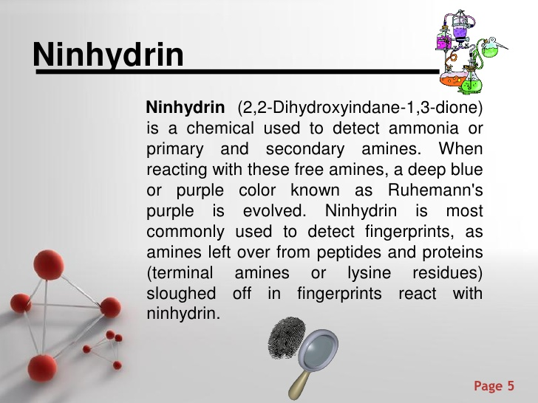
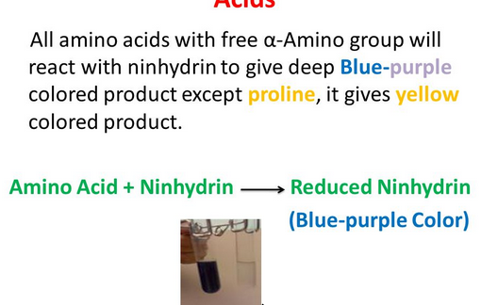
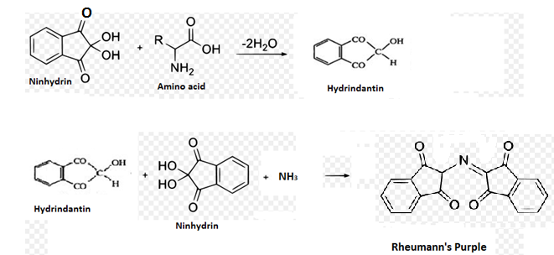
- Biuret test:
The biuret reagent (copper sulfate in a strong base) reacts with peptide bonds in proteins to form a blue to violet complex known as the “biuret complex”. N.B. Two peptide bonds at least are required for the formation of this complex.
Method
(a) Add 2 ml of protein solution to 1 ml of NaOH.
(b) Add one drop of Fehling's A.
(c)Shake this solution carefully and then you see purple color
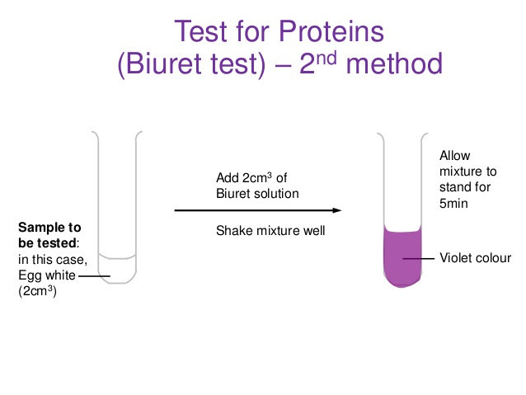
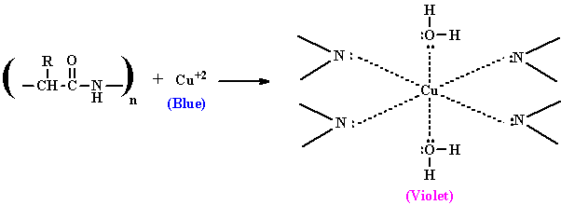

- Reduced sulfur test:
Principle:
Proteins containing sulfur (in cysteine and cystine) give a black deposit of lead sulfide (PbS) when heated with lead acetate in alkaline medium.
Method :
- To 1 ml of protein solution in a test tube, add 2 drops of 10% sodium hydroxide solution and 2 drops of lead acetate.
- Mix well and put in a boiling water bath for few minutes; a black deposit is formed with albumin and gelatin gives negative result.
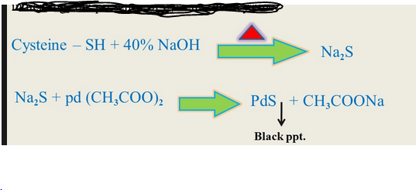

- Xanthoproteic acid test:
This test is used to differentiate between aromatic amino acids which give positive results and other amino acids. Amino acids containing an aromatic nucleus form yellow nitro derivatives on heating with concentrated HNO3. The salts of these derivatives are orange in color.

Principl
Concentrated nitric acid reacts with the aromatic rings that are derivatives of benzene giving the characteristic nitration reaction. Amino acids tyrosine and tryptophan contain activated benzene rings which are easily nitrated to yellow colored compounds. The aromatic ring of phenyl alanine dose not react with nitric acid despite it contains a benzene ring, but it is not activated, therefore it will not react.
Caution
Concentrated HNO3 is a toxic, corrosive substance that can cause severe burns and discolor your skin. Prevent eye, skin and cloth contact. Avoid inhaling vapors and ingesting the compound. Gloves and safety glasses are a must; the test is to be performed in a fume hood.
Procedure & observation
- To 2 ml of protein solution in a test tube, add 2 drops of concentrated nitric acid.
- A white precipitate is formed and upon heating in a boiling water bath, it turns yellow with “tyrosine” and orange with the essential amino acid “tryptophan” indicating a high nutritive value.
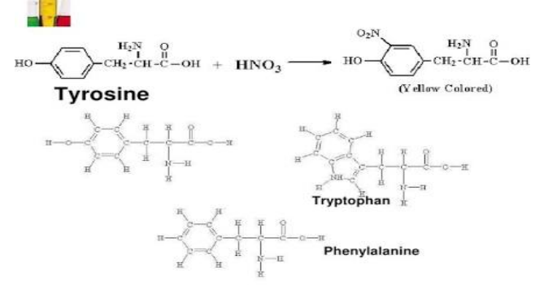

- Millon’s test:
This test is specific for tyrosine, the only amino acid containing a phenol group, a hydroxyl group attached to benzene ring
Principle:
In Milon's test, the phenol group of tyrosine is first nitrated by nitric acid in the test solution. Then the nitrated tyrosine complexes mercury ions in the solution to form a brick-red solution or precipitate of nitrated tyrosine, in all cases, appearance of red color is positive test.

Note
all phenols (compound having benzene ring and OH attached to it) give positive results in Millon’s test.

Procedure & observation:
- To 2 ml of protein solution in a test tube, add 3 drops of Millon’s reagent.
2- Mix well and heat directly on a small flame.
3-A white ppt is formed with albumin and casein (but not gelatin); the ppt gradually turns into brick red.
- Hopkins-Colé test:
Principle:
Hopkins-Colé reagent (magnesium salt of oxalic acid) gives positive results with proteins containing the essential amino acid “tryptophan” indicating a high nutritive value.
Procedure & observation:
- To 1 ml of protein solution in a test tube, add 1 ml of HopkinsColé reagent and mix well.
- Incline the test tube and slowly add 1 ml of concentrated H2SO4 on the inner wall of the test tube to form 2 layers.
3- Put the test tube in a boiling water bath for 2 minutes. 4- A reddish violet ring is formed at the junction between the 2 layers with albumin and casein; gelatin gives negative results

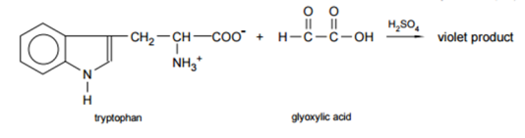

- Sakaguchi test
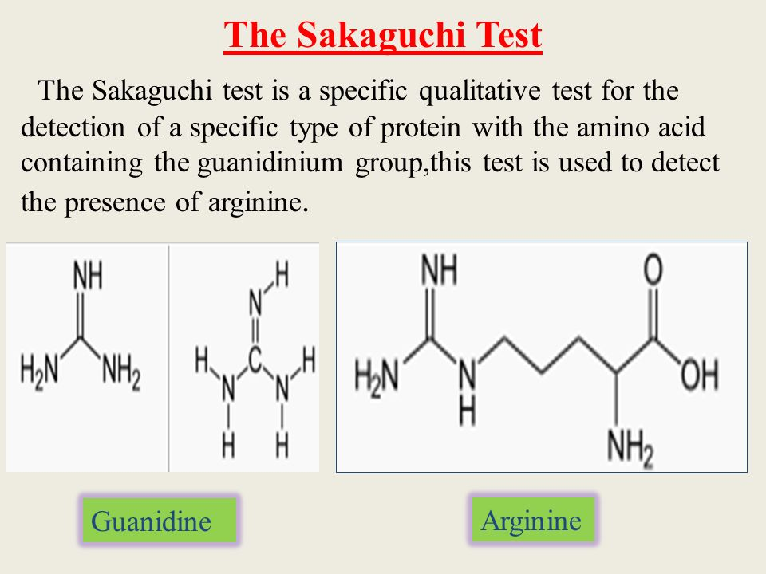
Method
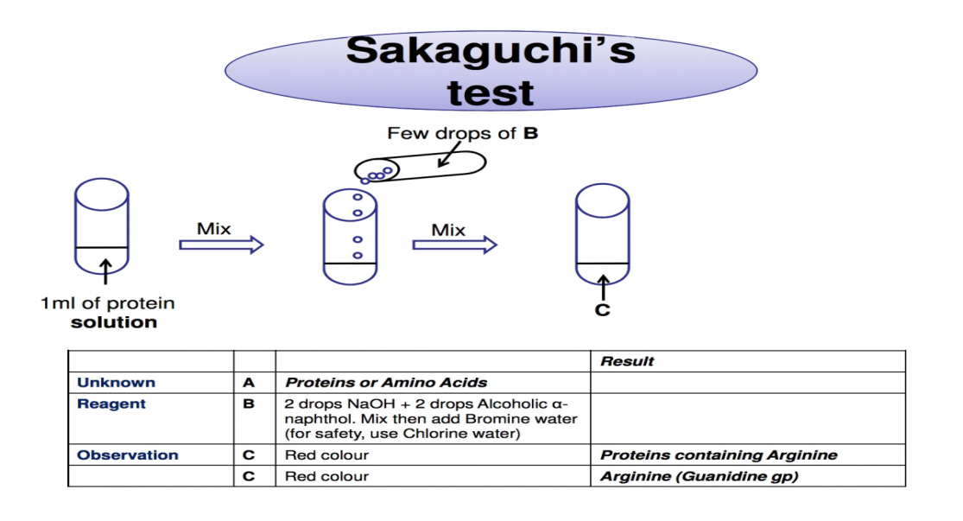

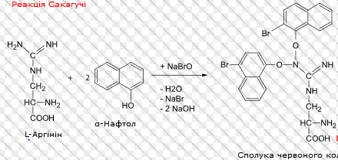

Precipitation reactions of proteins
- Precipitation by heavy metals:
Heavy metals (e.g. Hg2+, Pb2+, Cu2+) are high molecular weight cations. The positive charge of these cations counteracts the negative charge of the carboxylate group in proteins giving a precipitate. Procedure & observation:
- To 1 ml of protein solution in a test tube, add 1 drop of lead acetate; a white ppt is obtained.
2- To 1 ml of protein solution in a test tube, add 1 drop of 10% copper sulfate; a blue ppt is obtained.
- Precipitation by alkaloidal reagents:
Alkaloidal reagents (e.g. tannate & trichloroacetate) are high molecular weight anions. The negative charge of these anions counteracts the positive charge of the amino group in proteins giving a precipitate.
Procedure & observation:
- To 1 ml of protein solution in a test tube, add tannic acid drop wise until a buff ppt is obtained.
2- To 1 ml of protein solution in a test tube, add 1 ml of trichloroacetic acid (TCA); a white ppt is obtained.
N.B. Precipitation of proteins by heavy metals and alkaloidal reagents indicates the presence of both negative and positive charges and hence the amphoteric nature of proteins.

3. Precipitation by denaturation:
a. Denaturation by heat (heat coagulation test):
Heat disrupts hydrogen bonds of secondary and tertiary protein structure while the primary structure remains unaffected. The protein increases in size due to denaturation and coagulation occurs.
Procedure & observation:
- Put 2 ml of protein solution in a test tube, incline it and heat to boiling.
- A permanent clotting and coagulation is obtained with albumin only.
b. Denaturation by acids (Heller’s test):
Nitric acid causes denaturation of proteins with the formation of a white ppt (this differs from the nitration reaction in “xanthoproteic acid test”).
Procedure & observation:
- Put 2 ml of concentrated nitric acid in a test tube.
- Incline the tube and slowly add 1 ml protein solution drop wise to form a layer above the nitric acid layer.
- A white ring is formed at the interface between the 2 layers.
Fractional precipitation by ammonium sulfate (salting out):
Protein molecules contain both hydrophilic and hydrophobic amino acids.
In aqueous medium, hydrophobic amino acids form protected areas while hydrophilic amino acids form hydrogen bonds with surrounding water molecules (solvation layer).
When proteins are present in salt solutions (e.g. ammonium sulfate), some of the water molecules in the solvation layer are attracted by salt ions. When salt concentration gradually increases, the number of water molecules in the solvation layer gradually decreases until protein molecules coagulate forming a precipitate; this is known as “salting out”. As different proteins have different compositions of amino acids, different proteins precipitate at different concentrations of salt solution.
Procedure & observation:
- To 2 ml of egg-white solution (containing both albumin & globulin), add an equal volume of saturated ammonium sulfate solution; globulin is precipitated in the resulting half saturated solution of ammonium sulfate.
- Separate globulin by centrifugation and recover the clear supernatant.
- Add ammonium sulfate crystals gradually to the clear supernatant until full saturation occurs; another precipitate (albumin) is obtained.
4- Separate albumin by centrifugation.
N.B. The reason for the precipitation of globulin and albumin at different ammonium sulfate concentration could be that the solvation layer around globulin is looser and thinner than that around albumin. Therefore, globulin needs only half-saturated
ammonium sulfate to loose its solvation layer while albumin looses its solvation layer in a fully saturated ammonium sulfate solution.

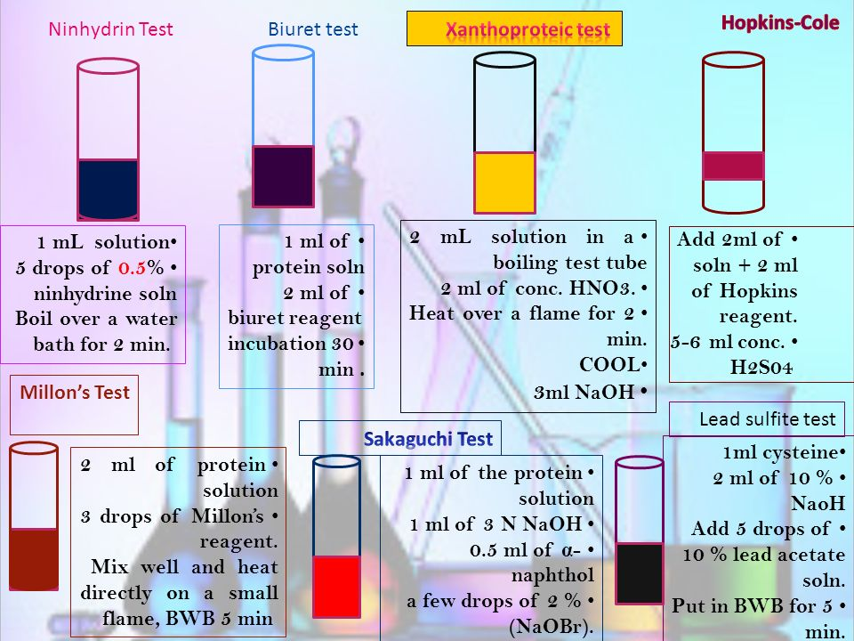

Laboratory exercise:
Using the provided solutions of albumin and gelatin perform the tests in the table below and write down your observations.
 | Albumin | Gelatein
Biuret test
Sulfer test
Xanthoprotic test
Heavy metal ppt
Heat coagulation
Hellers test

